Zewail City of Science, Technology and Innovation
University of Science and Technology
School of Computational Sciences and Artificial Intelligence

CSAI 203 - Fall 2025
EduTrack
Design Document

Team Number:29
Team Members:3
- Habiba Mohammed-202402213
- Ahmed Mahmoud-202401491
- Mohamed Essam-202401171
Representative Contact: s-ahmed.abda@zewailcity.edu.eg
Date: 22/11/2025

Table of Contents:
1. Introduction
1.1 Purpose of the Document
1.2 Scope of the Design Phase
1.3 Intended Audience
1.4 Overview of the Contents
2. System Overview
2.1 Brief Description of the System
2.2 Key Design Goals and Constraints
3. Architectural Design
3.1 System Architecture Diagram
3.2 Discussion of Architectural Style and Components
3.3 Technology Stack and Tools
4. Detailed Design
4.1 Model–View–Controller (MVC) Design Pattern
4.1.1 Description of MVC Pattern
4.1.2 Mapping of Project Components to MVC
4.1.3 Responsibilities of Model, View, and Controller
4.1.4 Interaction Between Components
4.2 UML Diagrams
4.2.2 Detailed Class Diagram
4.2.3 Sequence Diagrams
4.3 UI/UX Design
4.3.1 Wireframes / Mockups
4.4 Data Design
4.4.1 Database Schema / ER Diagram
4.4.2 File Structure / Data Storage Model (if applicable)
4.4.3 Data Dictionary
5. Conclusion
5.1 Summary of Design Phase

1. Introduction
1.1 Purpose of the Document
This design document serves as the definitive technical plan for the development of EduTrack Smart Classroom system. It translates the approved requirements outlined in the Software Requirements Specification (SRS) into practical design artifacts, including architectural diagrams, UML class diagrams, sequence diagrams, data schema, and interface mock-ups. The document will assist developers, testers, and stakeholders towards the implementation.
1.2 Scope of the Design Phase
The design phase includes the overall system architecture, the internal design of modules, mapping the pieces to the MVC, sequence diagrams for the significant use case, detailed class diagram, the database schema, and UI wireframes. This document is focused on design
1.3 Intended Audience
- Development team
- Test team
- Stakeholders involved in maintaining or extending the system
1.4 Overview of the Contents
This document contains:
- System overview
- Architectural design and technology stack
- MVC component mapping
- UML diagrams (class + sequence)
- UI wireframes
- Database schema and data dictionary
- Final design summary

2. System Overview

2.1 Brief Description of the System

EduTrack is an online smart classroom system created to improve communication and simplify academic processes between students and faculty. For example, it supports creating courses, uploading lectures, creating and submitting assignments, grading assignments, tracking attendance, chat messaging, a dashboards and notifications.

2.2 Key Design Goals and Constraints

Design Goals:
- MVC separation of concerns
- Scalability and modularity
- Secure handling of authentication
- Reliable file upload and storage
- Reusability and simple UI

Constraints:
- Flask + SQL backend
- HTML+CSS frontend
- Max file upload: 10MB

3. Architectural Design

3.1 System Architecture Diagram

https://drive.google.com/file/d/1ysKettSsG1R-1rTDJIhqi-iBG-pU8Fr8/view?usp=sharing
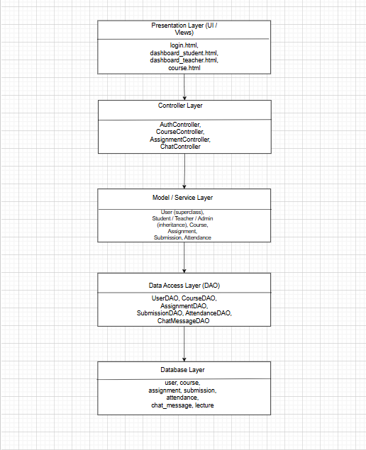

3.2 Discussion of Architectural Style and Components

EduTrack utilizes a Monolithic Model–View–Controller (MVC) architectural style. In a monolithic system, all aspects of the application, including views, controllers, models, and data access logic, are combined and deployed together as a single entity. This enables a very simplistic structure that is easy to develop and suitable for the scope of this project.

MVC architecture:

Views (Presentation Layer)These are the HTML/Jinja templates (such as login page, dashboards, course pages) that will present information to users and capture input.

Controllers (Controller Layer)

This is accomplished with Flask route functions. Controllers will receive user requests, authenticate requests, validate input, call the model/service functions, and return the appropriate view. Examples of controllers include AuthController, CourseController, AssignmentController, and ChatController.

Models / Services (Model Layer)

These represent the lifecycle of the system's main entities and business logic, such as User, Student, Teacher, Course, Assignment, Submission, Attendance, and ChatMessage. They have a duty of enforcing business rules, such as due dates, grading, or attendance status.

DAOs (Data Access Layer)

Data Access Objects are responsible for all interaction with the SQL database. DAOs complete CRUD functions and keep SQL queries separate from the business logic. Examples include UserDAO, CourseDAO, AssignmentDAO, and AttendanceDAO.

Overall, this architectural style clearly separates the responsibilities, producing a system that is more maintainable, organized, and easy to develop as a monolithic deployment.

3.3 Technology Stack and Tools
- Backend: Python (Flask)
- Frontend: HTML, CSS
- Database: SQL (SQLite / MySQL)
- Tools: Draw.io for Detailed class diagram , sequence diagram , mock-ups ,system architecture diagram

4. Detailed Design

4.1 Model–View–Controller (MVC) Design Pattern

4.1.1 Description of MVC Pattern

MVC divides the system into:
- Model — Manages data and business logic
- View — Responsible for UI rendering
- Controller — Handles requests, processes user actions, updates the model, and selects the view

EduTrack was built using the MVC pattern because of its clear separation of concerns, making the system easy to understand, develop, and maintain. The MVC pattern separates components to reduce coupling. The MVC pattern also

allows development to happen parallelly because it separates the user interface (UI) from the backend logic. The MVC pattern is natural fit for Flask web applications, which are inherently controller-based with routing. MVC keeps the EduTrack system modular and scalable, which will make it easier to extend with features in the future.

4.1.2 Mapping of Project Components to MVC

Model Classes
- User Student, Teacher, Admin (inherit from User in design)
- Course
- Enrollment
- Lecture
- Assignment
- Submission
- Attendance
- ChatMessage

Controller Classes
- AuthController – login, logout, register
- CourseController – create/join course, view course
- LectureController – upload/view lectures
- AssignmentController – create assignments, submit assignments
- AttendanceController – record & view attendance
- ChatController – send and display chat messages
- AdminController – manage users & system settings

Views
- login.html
- register.html
- dashboard_teacher.html
- dashboard_student.html
- course.html
- lectures.html
- assignments.html
- attendance.html
- chat.html
- admin_panel.html

4.1.3 Responsibilities of MVC Components

Model Responsibilities

The design incorporates Student, Teacher, and Admin as subclasses that inherit from base class User. All of them lie within the Model layer, representing different classes of system users that share the same fundamental attributes.
- Store system data
- Apply rules such as due date validation, grade constraints
- Map to database tables

View Responsibilities
- Display pages to users
- Provide forms for input (examples:upload assignment, create course)

Controller Responsibilities
- Authenticate users
- Handle course creation, joining
- Manage lecture upload
- Manage assignments and submissions
- Process chat messages
- Record attendance

4.1.4 Interaction Between Components

Overall Flow of the MVC Design Pattern

User interacts with a View

(as an example, submitting a form, clicking a button, or navigating to a page).

Controller receives the request

Controller will validate any input, check for authorization, and decide what action needs to be completed.

Controller communicates with Model

Model applies business rules (for example: validate due dates, calculate attendance status, verify user role, etc.).

Model accesses data using the DAO layer

DAOs perform SQL actions such as SELECT, INSERT, UPDATE, or DELETE.

The database returns data to the DAO → Model → Controller

Controller selects View

(HTML/Jinja template) and receives any data to display.

View renders the response to the user closing the loop.

Example: “Submit Assignment”
- View displays submission form
- Controller receives file
- Model validates file
- DAO saves record in DB
- View confirms success

4.2 UML Diagrams 4.2.2 , 4.2.3 , 4.3.1 , 4.4.1

4.2.2 Detailed Class Diagram

https://drive.google.com/file/d/13yu7-M-SJFe8fPSzTOVcUkoN18AqkLze/view?usp=sharing

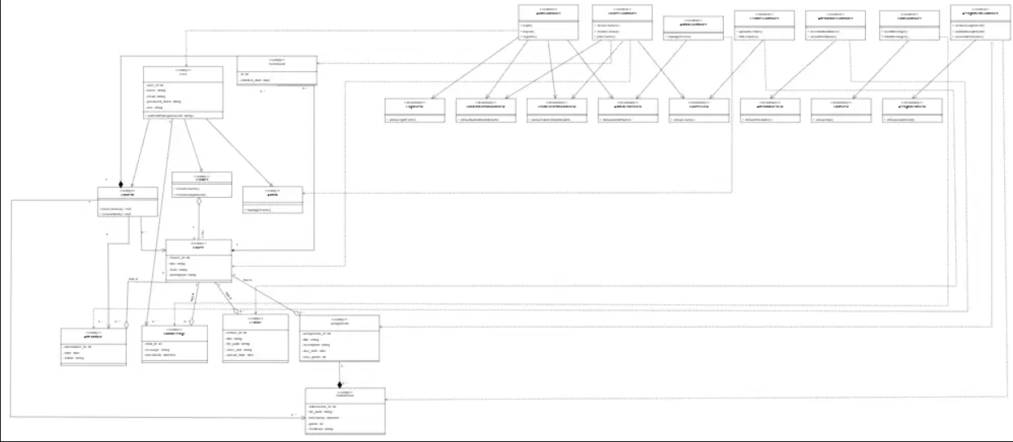

4.2.3 Sequence Diagrams//

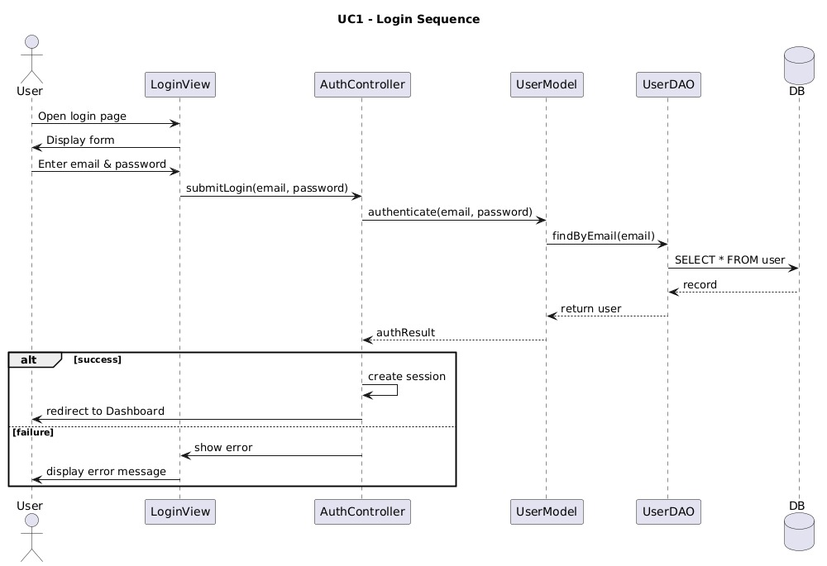

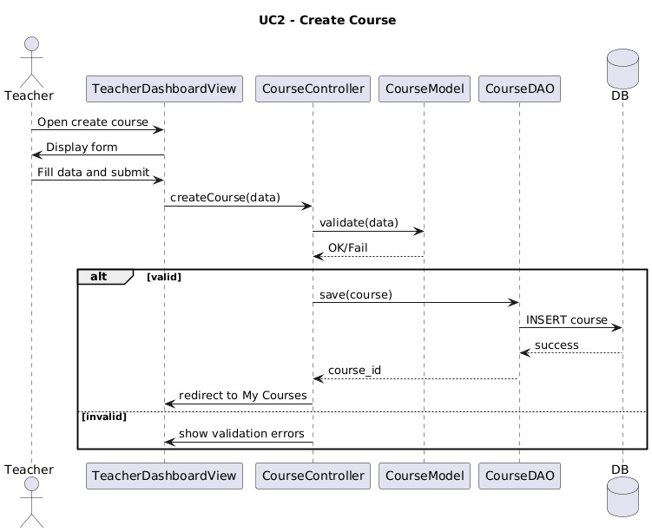

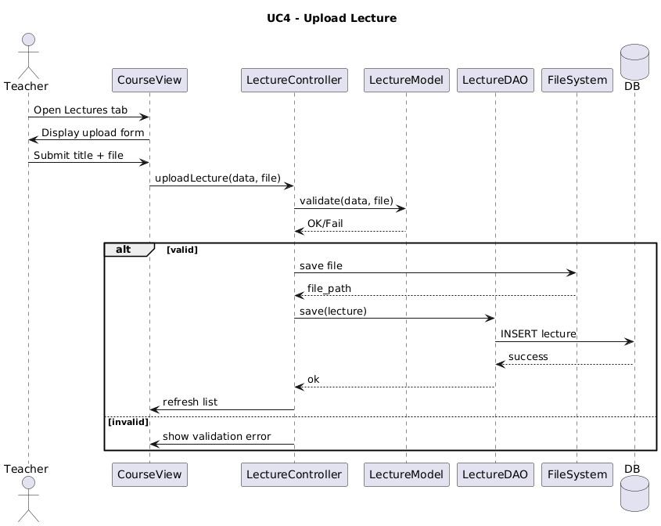

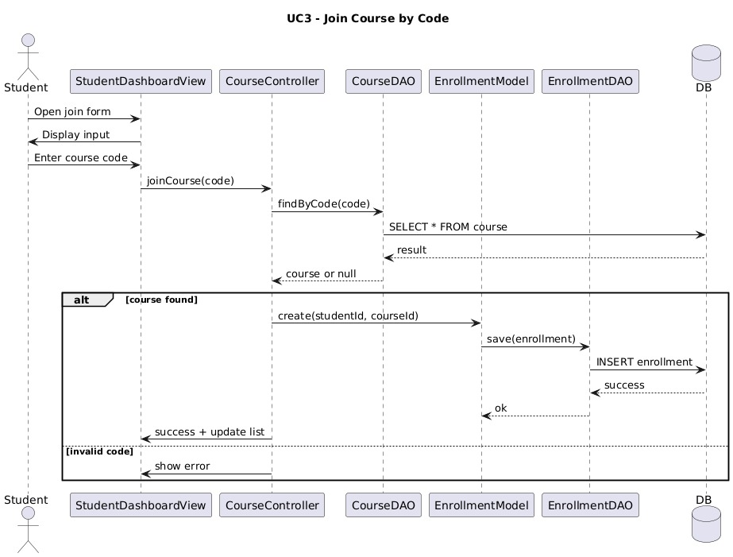

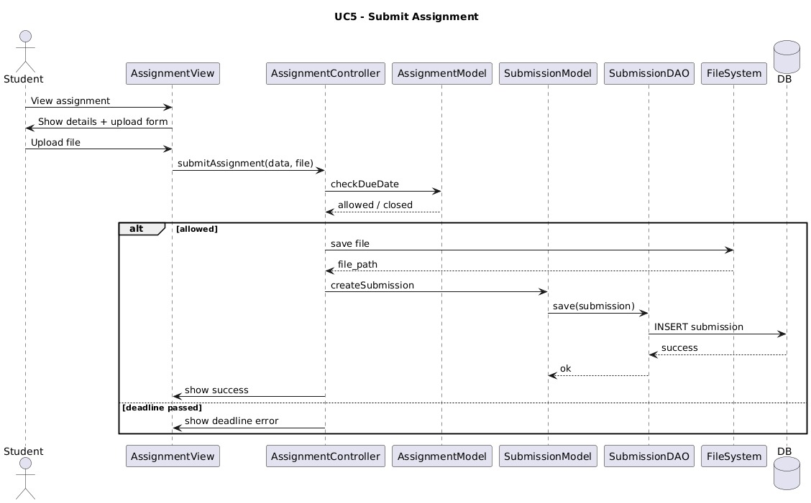

4.3 UI/UX Design

4.3.1 Wireframes

https://drive.google.com/file/d/1UjB-WCmmxT_XFo4UVlVI1WBtE-eg7tKv/view?usp=sharing

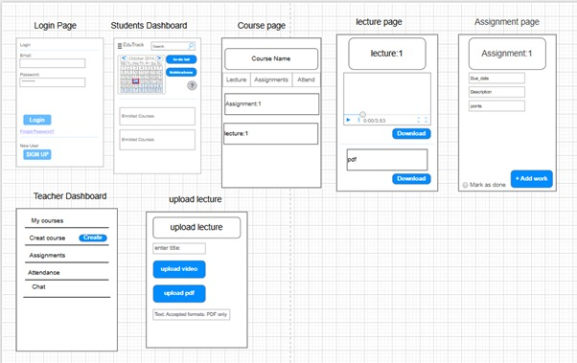

4.4 Data Design

4.4.1 Database Schema / ER Diagram

https://drive.google.com/file/d/1iLouvpWXSDerqqS63dWAMuRkZ_X5NNQ-/view?usp=sharing

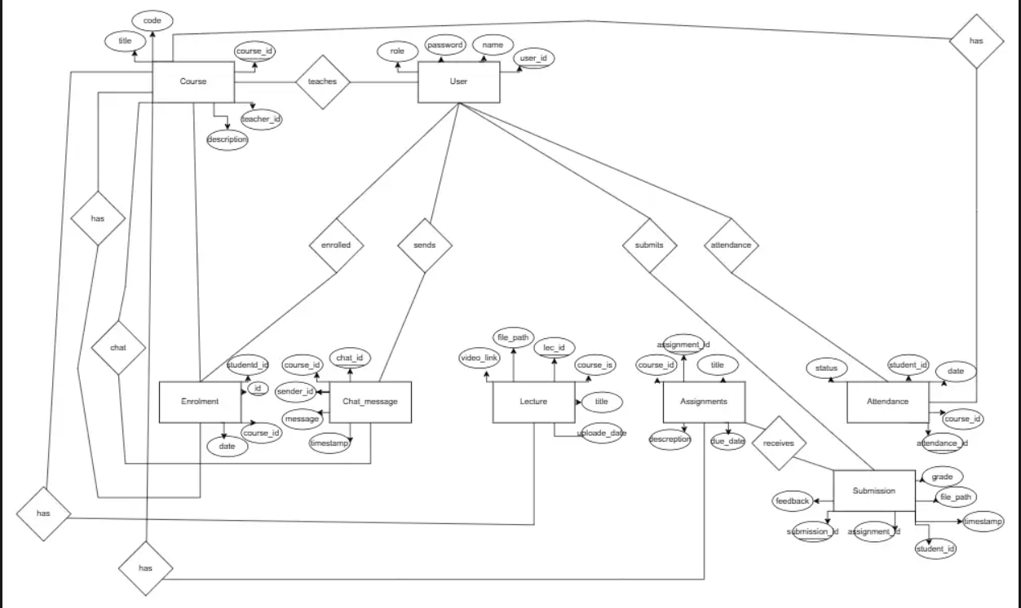

4.4.3 Data Dictionary

User Table

Note: In the class diagram, Student, Teacher, and Admin inherit from User. However, in the database all roles are stored in this table.
Column | Data Type | Description / Purpose
user_id | INT (PK) | Unique identifier for each user.
name | VARCHAR | Full name of the user.
email | VARCHAR | User login email; must be unique.
password | VARCHAR | Hashed password for secure authentication.
role | ENUM | indicates user type: student, teacher, admin (used for inheritance logic).

Course Table
Column | Data Type | Description / Purpose
course_id | INT (PK) | Unique identifier for each course.
teacher_id | INT (FK) | References User.user_id of the teacher who owns the course.
title | VARCHAR | Course title displayed to users.
code | VARCHAR | Join code used by students to enroll in the course.
description | TEXT | Course description and overview.

Enrollment Table
Column | Data Type | Description / Purpose
id | INT (PK) | Unique identifier for each enrollment record.
student_id | INT (FK) | References User.user_id for the enrolled student.
course_id | INT (FK) | References Course.course_id for the enrolled course.
enrolled_date | DATE | Date when the student joined the course.

Lecture Table
Column | Data Type | Description / Purpose
lecture_id | INT (PK) | Unique identifier for each lecture.
course_id | INT (FK) | References Course.course_id to link lecture to a course.
title | VARCHAR | Title or topic of the lecture.
file_path | VARCHAR | Path on the server to the uploaded lecture PDF file.
video_link | VARCHAR | Optional URL to an external video resource.
upload_date | DATE | Date the lecture was uploaded.

Assignment Table
Column | Data Type | Description / Purpose
assignment_id | INT (PK) | Unique identifier for each assignment.
course_id | INT (FK) | References Course.course_id for the course that owns the assignment.
title | VARCHAR | Assignment title.
description | TEXT | Detailed description of the task.
due_date | DATE | Deadline for submission.
max_grade | INT | Maximum possible grade for the assignment.

Submission Table
Column | Data Type | Description / Purpose
submission_id | INT (PK) | Unique identifier for each submission.
assignment_id | INT (FK) | References Assignment.assignment_id.
student_id | INT (FK) | References User.user_id for the student who submitted.
file_path | VARCHAR | Path to the uploaded submission file on the server.
timestamp | DATETIME | Date and time when the submission was uploaded.
grade | INT | Grade given by the teacher (nullable until graded).
feedback | TEXT | Textual feedback from the teacher (nullable).

Attendance Table
Column | Data Type | Description / Purpose
attendance_id | INT (PK) | Unique attendance record identifier.
course_id | INT (FK) | References Course.course_id.
student_id | INT (FK) | References User.user_id for the student.
date | DATE | Session date.
status | ENUM | Attendance status: Present, Absent, or Excused.

ChatMessage Table
Column | Data Type | Description / Purpose
chat_id | INT (PK) | Unique identifier for each chat message.
course_id | INT (FK) | References Course.course_id indicating the course chat.
sender_id | INT (FK) | References User.user_id of the message sender.
message | TEXT | Content of the chat message.
timestamp | DATETIME | Date and time when the message was sent.

5. Conclusion

5.1 Summary of Design Phase

The design stage of the EduTrack system specified how the software will operate internally based on requirements collected in the SRS. This document describes a complete architecture following the MVC pattern and includes definitions for system components, models, controllers, and view. This document also describes the behaviour and interactions of the EduTrack system and includes sequence diagrams, detailed class diagram, wireframe mock-ups. The data layer has been defined through a complete database schema and data dictionary. The results of this phase can be used in the implementation phase and will ensure that the system can be modular, maintainable, scalable, and satisfy all the requirements.

